**DAILY ONLINE ACTIVITIES SUMMARY**

|  |  |  |  |  |  |  |  |  |
| --- | --- | --- | --- | --- | --- | --- | --- | --- |
| **Date:** | **31-05-2020** | | | | | **Name:** | **Raksha S** | |
| **Sem & Sec** | **6th B** | | | | | **USN:** | **4AL17CS073** | |
| **Online Test Summary** | | | | | | | | |
| **Subject** | |  | | | | | | |
| **Max. Marks** | |  | | **Score** | | |  | |
| **Certification Course Summary** | | | | | | | | |
| **Course** | **FullStack Webdevelopment** | | | | | | | |
| **Certificate Provider** | | | **Greatlearning** | | **Duration** | | | **45 days** |
| **Coding Challenges** | | | | | | | | |
| Problem Statement: 1. Write a c program to solve a system of linear congruence’s by applying the Chinese Remainder Theorem.  2. This java program shows the string interleaved or not. | | | | | | | | |
| **Status:** YES, Completed all Programs | | | | | | | | |
| **Uploaded the report in Github** | | | | | **YES** | | | |
| **If yes Repository name** | | | | | <https://github.com/raksha05/Daily-Status>/Raksha-4AL17CS073/Raksha | | | |
| **Uploaded the report in slack** | | | | | **YES** | | | |

Certification Course Details:

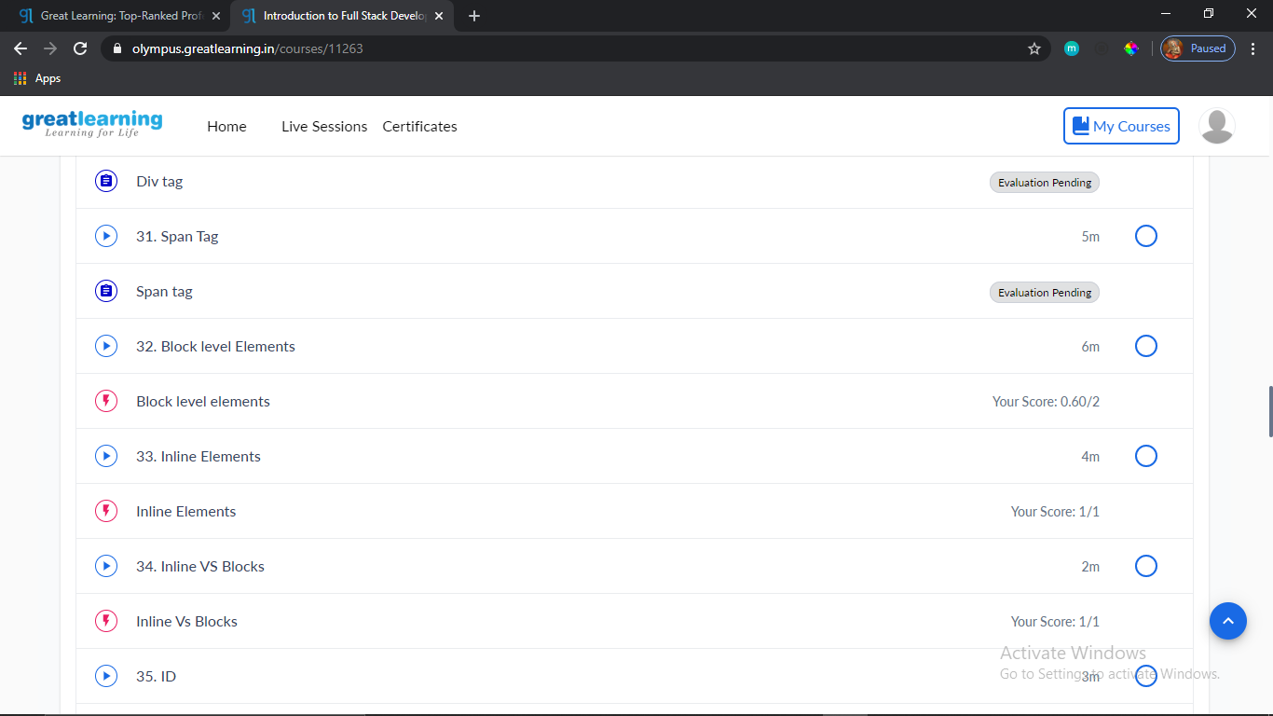

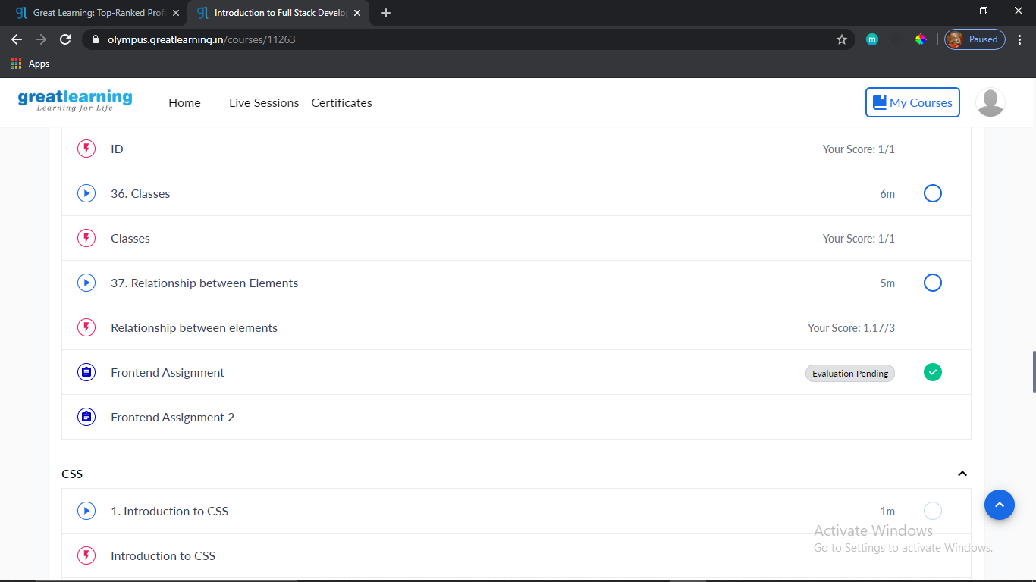

The above course is being taken up by me is based on Fullstack Webdevelopment. Today in online course I studied about div and span tags difference between div and span tags,div is block level element and span,anchor,img tags are inline elements.And learnt about id,classes and where to use that,and what all behaviour we can see using these elements.And submitted the Frontend assignment1.

Coding Challenges Details:

Program1:

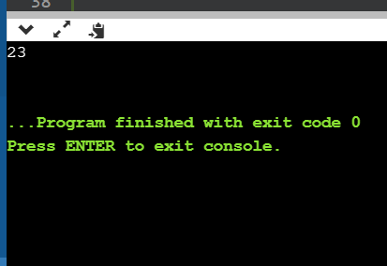

Program2:

